**Dry Beans Classifier – NN – Task 2**

**Team_ID: 11**

**Team Members**

|  |  |  |
| --- | --- | --- |
| Name | ID | Department |
| أحمد حسن حسن خطاب | *20201700033* | Computer Science(CS). |
| انس سعيد صبري | *20201700159* | Computer Science(CS). |
| عبدالرحمن هاني خيري الدين | *20201700488* | Computer Science(CS). |
| أحمد هاني حامد محمد | *20191700875* | Computer Science(CS). |
| عمر رضا عبدالدايم عبدالعزيز | *20201701267* | Computer Science(CS). |

**Multilayer Perceptron**

**Combination#1**

* **Inputs:**

**Learning rate: 0.01.**

**Number of epochs: 1000.**

**Hidden Layers: 1.**

**Neurons in each layer: 300.**

**Use Bias ?: No.**

**Activation Function: Sigmoid.**

* **Train Accuracy : 100 %.**
* **Test Accuracy: 100 %.**
* **Screen shot:**

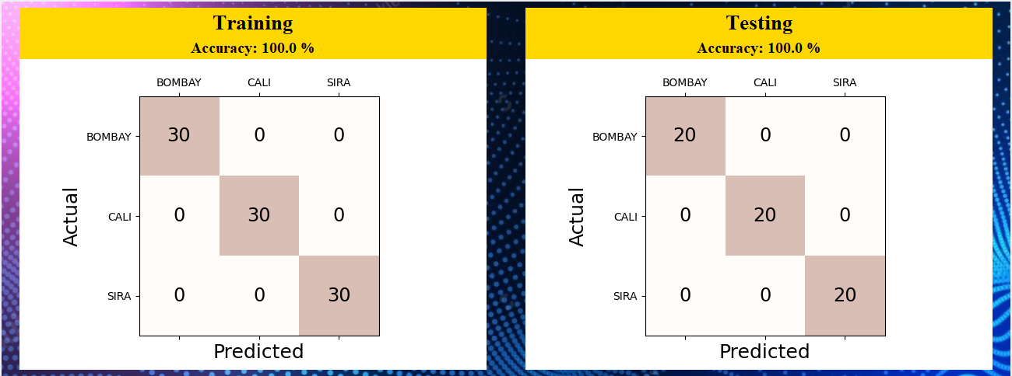

**Combination#2**

* **Inputs:**

**Learning rate: 0.0001.**

**Number of epochs: 5000.**

**Hidden Layers: 3.**

**Neurons in each layer: 64 , 32 , 16.**

**Use Bias ?: Yes.**

**Activation Function: Tanh.**

* **Train Accuracy : 100 %.**
* **Test Accuracy: 100 %.**
* **Screen shot:**

